ISU WORLD CUP SHORT TRACK
December 9-11, 2022
Almaty, Kazakhstan

Media Information

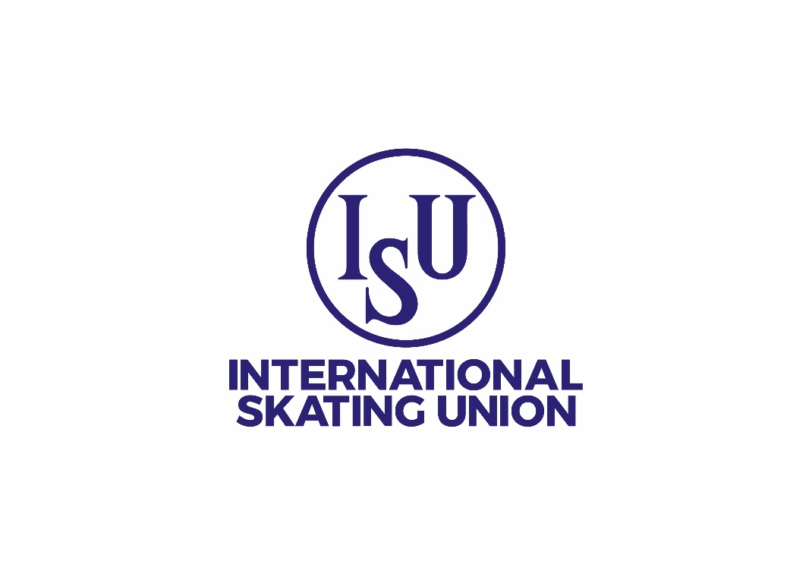

Table of Contents

1. Media Accreditation 3
1.1 Accreditation Requirements 3
1.2. Quotas 3
1.3. Accreditation types and deadlines 4
1.4. Restrictions to Media Non-Right Holders during ISU Events 4
1.4.1. Restricted areas 4
1.4.2. Authorized areas 5
1.5. TV and Radio Rights Holders 5
1.6. Accreditation Confirmation 5
2. Covid-19 Measures 5
3. Visa Application 5
4. Media Facilities at the venue 5
4.1. Media Tribune and TV Commentator positions 6
4.2. Mixed Zone & Press Conferences 6
5. Media Services 6
6. Media Accommodation 7
6.1. Media Hotels 7
6.2. Reservation Payment Conditions 7
7. Transportation and Telecommunications 7
7.1. Transportation 7
7.2. Telecommunications 8
8. Useful Information 8
9. Competition information 8

National Skating Federation of Kazakhstan looks forward to hosting media attending the ISU World Cup Short Track in Almaty, Kazakhstan. The event will be held at the Halyk Arena from December 9, 2022.

This information will assist you in planning your trip to Almaty and to apply for media accreditation to cover the event. Every effort will be made to ensure journalists have all the appropriate facilities necessary to work at the event.

The Press Centre and press tribunes will be open and operational for the first practice/ training session as from December 5, 2022 according to the following time schedule (it may be subject to changes and needs to be verified on-site):

Working hours according to the training schedule of the teams
- Media Accreditation
All media must apply for media accreditation through the ISU Online Media Accreditation System (OMAS) on the International Skating Union (ISU) website (www.isu.org) under «Media Accreditation».

Only professional journalists, editors and photographers covering the ISU Event for editorial purposes, or producing content for news purposes, will be accredited.

1.1 Accreditation Requirements
All media must provide the following documentation when applying for media accreditation and further information could be requested (such as evidence of past articles, etc.):
- Endorsement Letter from the editor-in-chief (formats: pdf, png or jpeg) - Mandatory
- Copy of current professional media or journalist card (formats: pdf, png, or jpeg) – if available
- ID photo (formats: pdf, png or jpeg) - Mandatory
- Present the necessary documentation as requested by the OC, and which may include sanitary certifications/testing results - Mandatory

1.2. Quotas
If space is limited the following quota will be enforced:
Type of Media | Number of people per media organization
Writing Press | Media Organization (newspaper, magazine, web, agencies, ISU Member Federations) : 1 journalist
 | Agency, Major Newspaper: 2 journalists
Photographer | Media Organization: 1 photographer
 | Agency, Major Newspaper: 2 photographers (limited to one rink side position, the other in an elevated position for Figure Skating, Synchronized Skating and Short Track Speed Skating. For Speed Skating, space permitting 2 rink side positions could be possible)
TV Non-Right Holder | Media Organization: 3 person crew max. (e.g. one reporter, one camera person, one editor)
Radio Non-Right Holder | Media Organization: 1 reporter (max.)
Freelancer | Freelance journalist or photographer: 1 person  - Freelancers must provide written evidence that they are assigned to cover the ISU Event by a media organization.  - A freelancer operating under their own account may be requested to submit additional written evidence (presentation letter, copy of past editorial pieces etc).

1.3. Accreditation types and deadlines
The International Skating Union (ISU) and the Organizing Committee have been working diligently to ensure there will be ample coverage opportunities available to media outlets wishing to cover the ISU events either on-site or remotely. This in mind, there will be two types of media accreditations issued:

- On-site media accreditations will be subject to capacity.

- Remote media accreditation holders will not have access to the venue and will be covering the event virtually.

The deadlines to apply for media accreditations are as follows:

- On-site media accreditation requests: Tuesday, November 29, 2022

- Remote media accreditation requests: Tuesday, November 29, 2022

No late media accreditation applications will be accepted for on-site requests.

1.4. Restrictions to Media Non-Right Holders during ISU Events
Non-Right Holders media – print/web journalists, TV/Radio, photographers, content creators and social media reporters – who have not negotiated any special production rights – need to abide and agree to the following rules in the conduct of their editorial work during ISU events (see Terms and Conditions here).
    - Restricted areas
Filming in the below listed areas is strictly forbidden:
- Training sessions (at the Practice or Main rinks)
- Warm-up zone
- Changing rooms
- Mixed Zone area (unless approval has been provided by the ISU and its TV partners in advance)
- Competitions / Field of play
- From public seats at all times (even during ice resurfacing)

    - Authorized areas
Non-Right Holders media are only allowed to produce video, audio-recorded material for editorial purposes in the following areas:
- In the Press Conference room
- Outside the venue

Special filming permissions may be submitted to the ISU Media Team (media@isu.ch) in advance of the event. The transgression of any of these rules may result in the exclusion from ISU Events, removal of accreditation and legal actions.

1.5. TV and Radio Rights Holders
All right holding media must also apply for accreditation via OMAS. Access to the Right Holders area is restricted, therefore Right Holders are invited to contact the ISU Media Team media@isu.ch in order to obtain a username and password.

To book any broadcasting services or facilities please contact the host Broadcaster:
Inna Tribelgorn
OC Host Broadcaster
Telephone: +7017555270
Email address: inna@nsp.asia

  - Accreditation Confirmation
If the accreditation request – either on-site or remote - is accepted, an automatic email of confirmation will be issued. For on-site attendance, you may be asked to present a copy of the email of confirmation to receive your accreditation badge.

You will also be notified if your accreditation request is denied. Please note that the ISU and OC reserve the right to refuse accreditation with or without justification.

Accreditation will be distributed to media in the Press Centre during opening hours, beginning Thursday,
October 27 from 10:00am.
- Covid-19 Measures
During the current Covid-19 pandemic the health and safety of all participants at the ISU Events including the athletes, team members, officials, volunteers, service providers, broadcasters, media, and spectators needs to be given additional attention.
Therefore, each participant is required to carefully read the ISU Guidelines for ISU Events During COVID-19 pandemic (General Guidelines and Short Track specific Guidelines).

- ISU Guidelines for ISU Events During COVID-19 Pandemic: https://isu.org/inside-isu/covid-19

Furthermore, specific procedures and additional Covid-19 guidelines will be communicated by the Organizing Committee closer to the Event.

- Visa Application
Media representatives requiring an official invitation letter in order to apply for a visa must contact the Organizing Committee Ms. Akaisha Ospan, ss@skating.kz Please note that an official invitation letter will only be provided to approved media representatives.

For visa request, please provide passport details and name of the Embassy where it will be applied.
- Media Facilities at the venue
Directions in the form of arrows will lead you to the Press Center in the Halyk Arena. The Organizing Committee and Volunteers will help, if required. The entrance leads directly to the Press Center and the Mix Area. The room includes workplaces with wireless Internet access, as well as a TV for watching competitions. Accredited media will be provided with drinks (coffee, water, etc.) and snacks.

4.1. Media Tribune and TV Commentator positions
The OC will organize separate seats on the podium for the Media if necessary. We also kindly ask Media Members to follow the rules of accredited zones and stay only in permitted zones as indicated on accreditation.

4.2. Mixed Zone & Press Conferences
The Mixed Zone provides an opportunity for media to interview athletes immediately after competition. It is split into five main sections and follows a pre-determined priority order:
- Quick Quotes (available through the ISU website)
- TV and Radio Rights Holders who have pre-booked positions
- ENG crews
- Non-Right Holders (written/web press, TV/Radio, social media without any production rights)
- Virtual Mixed Zone
Athletes with requests will pass through the Mixed Zone on completion of every event. Coaches may also be requested for interviews, if required. The Press Officer and ISU Media teams will do their best to make sure that requested skaters go through the Mixed Zone for media interviews, but are also responsible to ensure that the medallists get to their ceremony on time and return to the Mixed Zone to finish TV interviews, before then attending Press Conferences.
The Mixed Zone is located on the left side of the Press Center.
Press conferences, will feature the top-3 finishers after the competition. They will take place after the races/segments for all four disciplines.

All remote media accreditation holders will be able to access the virtual Press Conferences through a Zoom link provided on the ISU Inside Event App. Once in the Zoom room, those wanting to ask a question will be asked to notify the moderator by using the chat or raise hand function. The moderator will call on those wanting to ask a question.

All interview requests must be forwarded in advance to the OC press officer who will work with the media.
- Media Services
- Press Conference: Click Here to subscribe to the latest Press Releases
- Quick quotes: Please refer to ISU website.
- Press Releases
- Media Guide
- To access ISU photo galleries for editorial and non-commercial purposes, click here. When using a picture, the ISU must be credited as follows: ©International Skating Union (ISU) and must be tagged or mentioned in any social media post.
- OC Photographer Mr. Sali Sabirov, sabirovst@gmail.com
- ISU photo galleries: Picture Galleries - International Skating Union (isu.org)
- Social Media accounts:
- Instagram: @qaz.iceteam
- TikTok: @qaz.iceteam
- Event Hashtags: #Almatyice #Qaziceteam #Halykarena #Shorttrackskating #WCALA2022
- Event Website: www.skating.kz

Connect with ISU official channels for all the latest and live information:
- ISU website
- Event webpage www.skating.kz
- ISU Newsletter subscription
- Facebook: @ISUFigureSkating / @ISUSpeedSkating / @ISUShortTrackSpeedSkating
- Instagram: @ISUFigureSkating / @isuspeedskating
- Youtube: Skating ISU
- Twitter: @ISU_Figure / @ISU_Speed
- Tik Tok: @isuskating
- Weibo: weibo.com/isuofficial
- LinkedIn: https://www.linkedin.com/company/international-skating-union

Inside ISU Event App:
- The Inside ISU Event App is the main source of information and means of communication for media attending ISU Events on-site or remotely.
- It gathers all the key media-related information (competition schedule, media areas operating hours, contacts, virtual mixed zone, transportation, press releases, entries/results, etc.), constantly updated live with push notifications alerts.

The credentials to access the Media channel of the relevant Event is provided via OMAS once an accreditation is approved.

- Media Accommodation
The OC has designated official hotels for the ISU Event. Also, the OC informs that due to limited capacity the priority for rooms will be given to teams. In case of additional space is available at their hotels, rooms could be offered to accredited media.

Every individual media person is responsible for booking their own accommodation and bearing any cancellation fees.

6.1. Media Hotels

Hotel Garden Park Inn
137/139 Baitursynova str.
Reservation: info@qrtip.kz

Hotel SADU
128/7 Al-Farabi Avenue (Almaty)
Reservation: info@qrtip.kz
there is a fitness club on the territory of the hotel, the cost for hotel residents is 10,000 tenge for all directions during the day (gym, cycling, spa and swimming pool, group classes)
Invictus Sadu (invictusfitness.kz)
Hotel requirements must be communicated to the Organizing Committee as soon as possible, but no later than Friday November 11, 2022.

6.2. Reservation Payment Conditions

In case of no-shows or cancellation of hotel rooms after Sunday, December 4, 2022, the ISU Member concerned will be charged 80% of the total costs by the Organizing Committee.
For more details, please contact info@qrtip.kz

- Transportation and Telecommunications

7.1. Transportation

Shuttle transportation will be arranged from all the official hotels to the Halyk Arena. Shuttle schedules will be provided on site. Please be advised that the transportation service will only be available for the designated official media hotels.

The Organizing Committee will also provide transportation between the official hotel and Halyk Arena during the competition days and the training periods, starting from Monday, December 5, 2022.
Transportation between the official hotels and the Halyk Arena until December 5, 2022 will be on a paid basis of 15 US$ per person each way. Payment can be made by sending an invoice or in cash at the OC office in Halyk Arena.

7.2. Telecommunications
The room includes workplaces with wireless Internet access, as well as a TV for watching competitions. Accredited media will be provided with drinks (coffee, water, etc.) and snacks.
- Competition information
Entry List: click here
Results: click here
Rankings: click here

For any additional questions or information, please do not hesitate to contact:

National Skating Federation of Kazakhstan
47, Kabanbay Batyra, Astana
E-mail: kalymmova@gmail.com
Tel: +7 777 309 5980
Ms. Marzan Kalymova

All information concerning the competition will be available at the following Event website: www.skating.kz
Live results will be available on www.isu.org

